**Testing**

Following the navigation bar, if you press breakfast it will lead you to this page, with the breakfast recipes. If you press the lunch, dinner or desserts in the navigation it won’t lead anywhere as there are only 3 pages in this website.

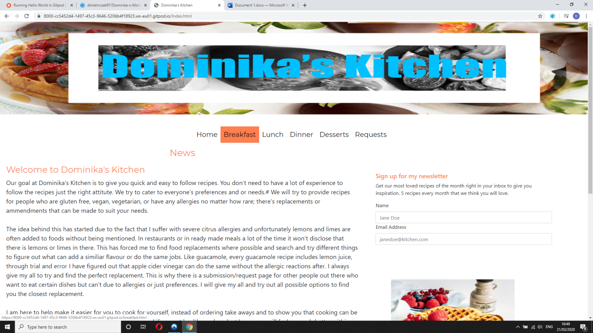

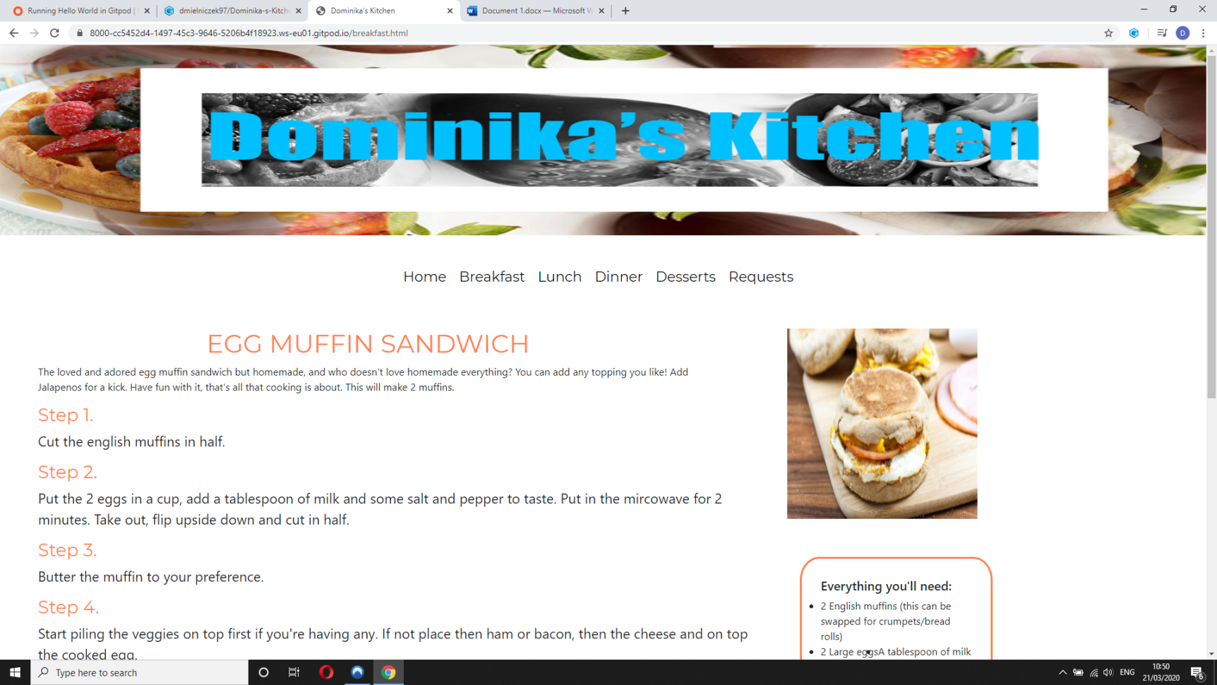

If you press requests on the navigation bar, it will lead you to the requests page as shown here.

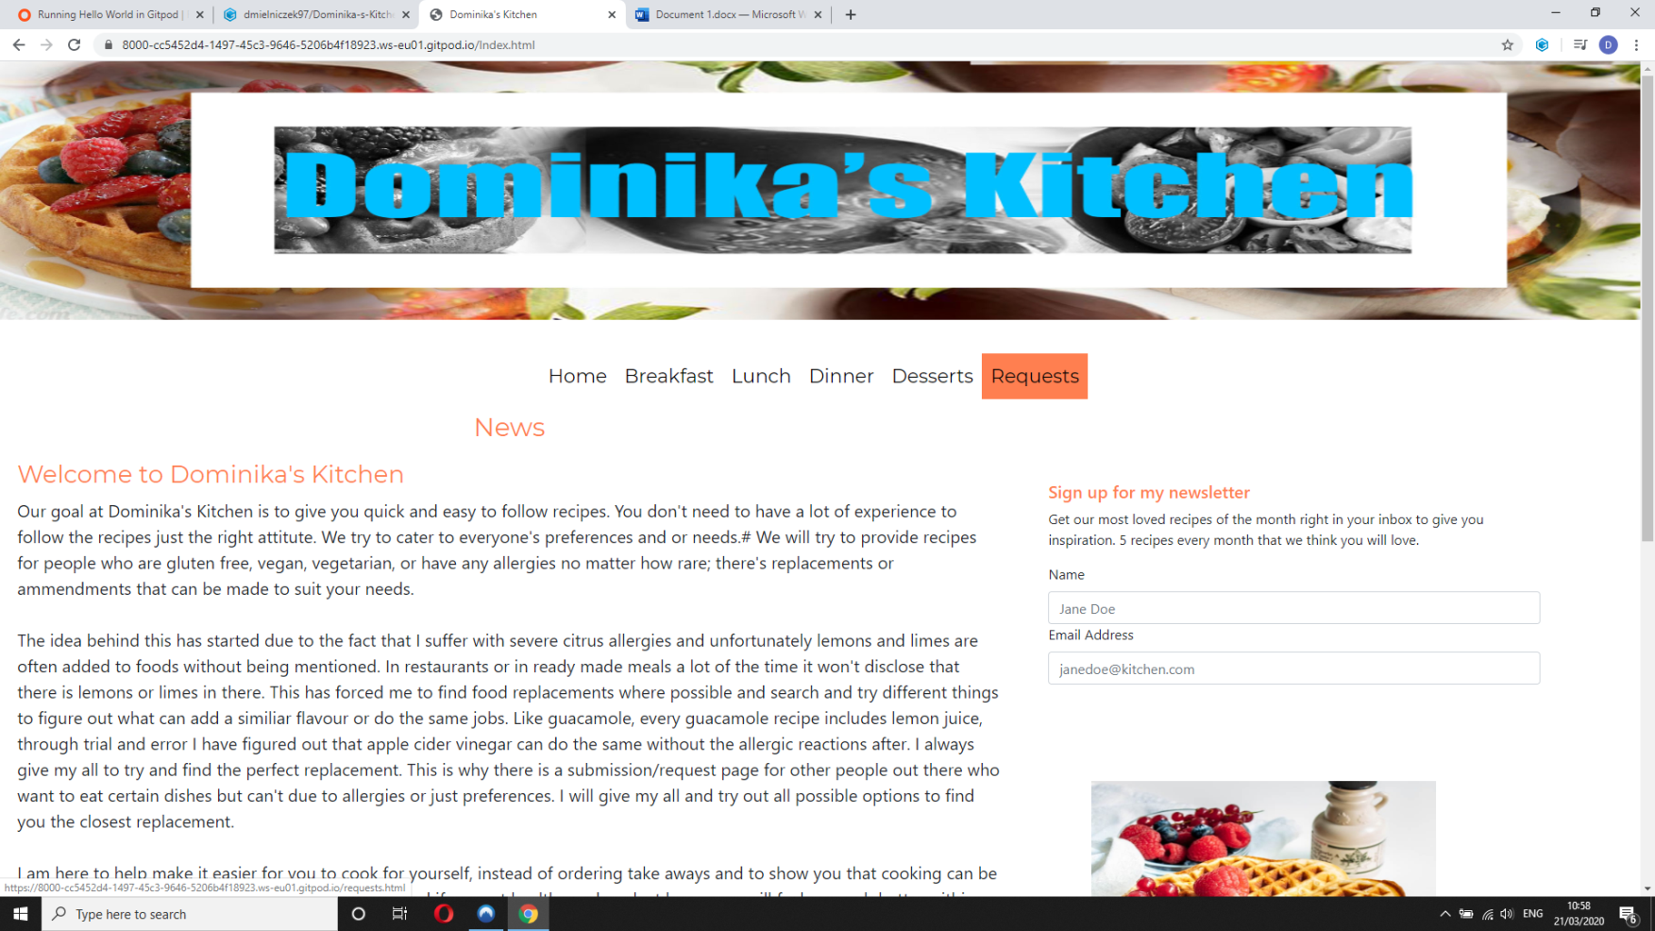

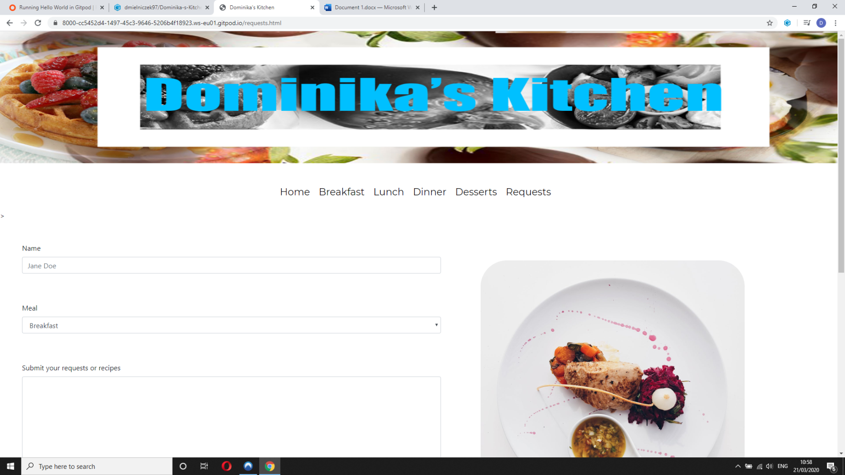



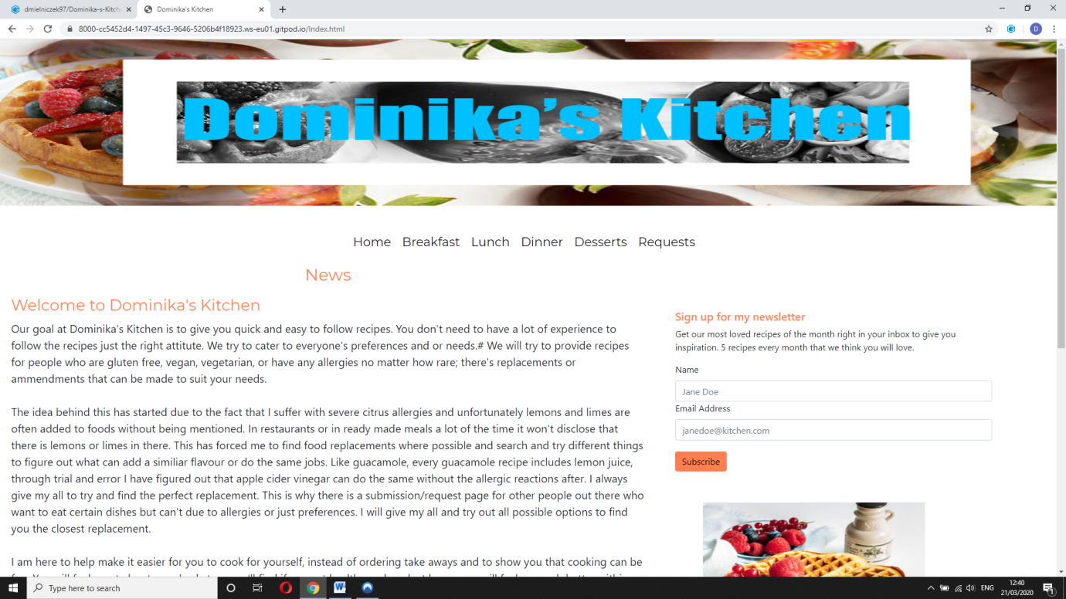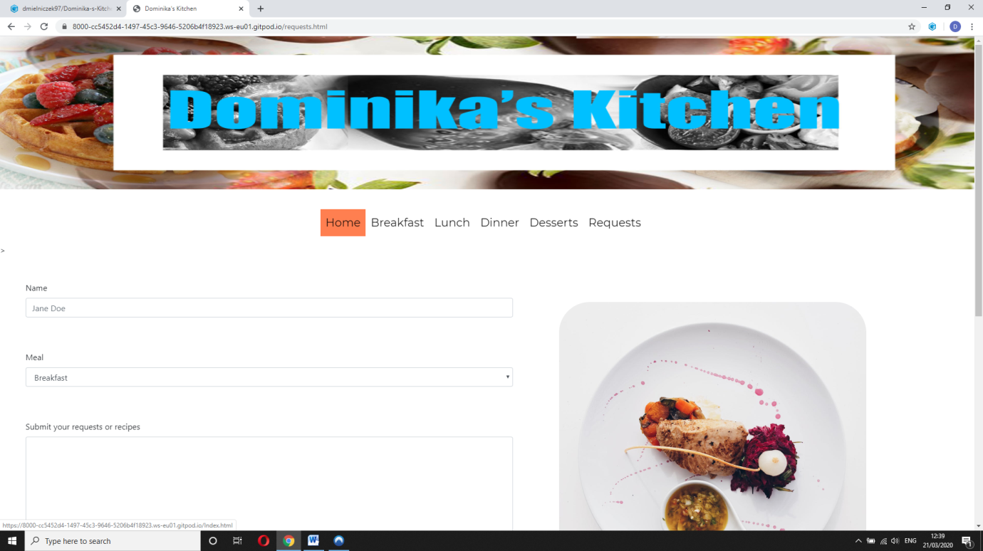When pressed home, it will take you to main home page called index.html as shown below.

**Responsiveness**

The requests page on a tablet would look like this. I removed the picture from the tablet and phone version as it’s not relevant. Everything the user will need or want has still remained on the page.

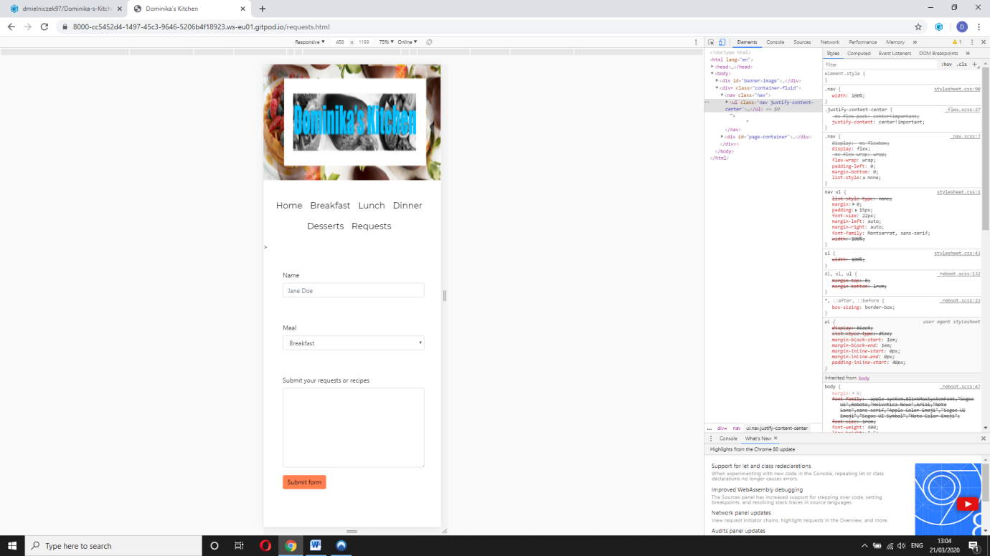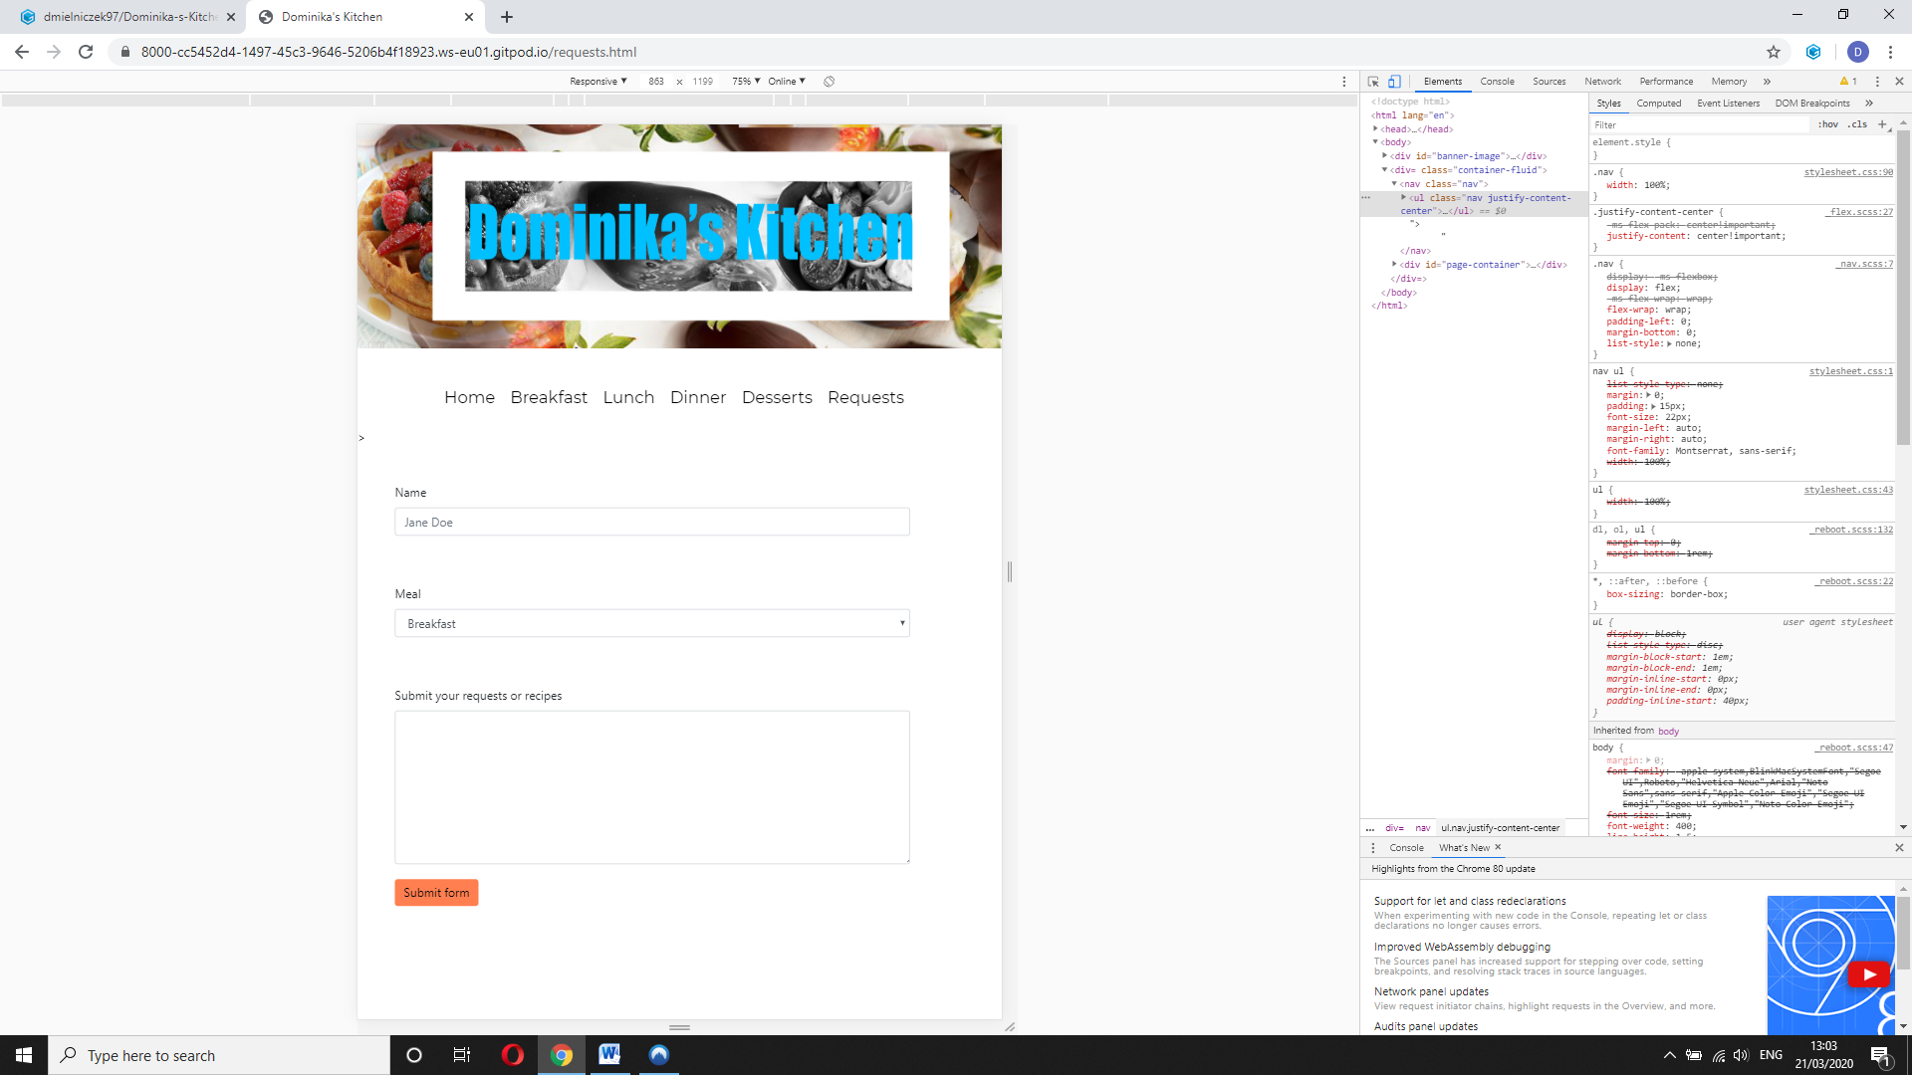

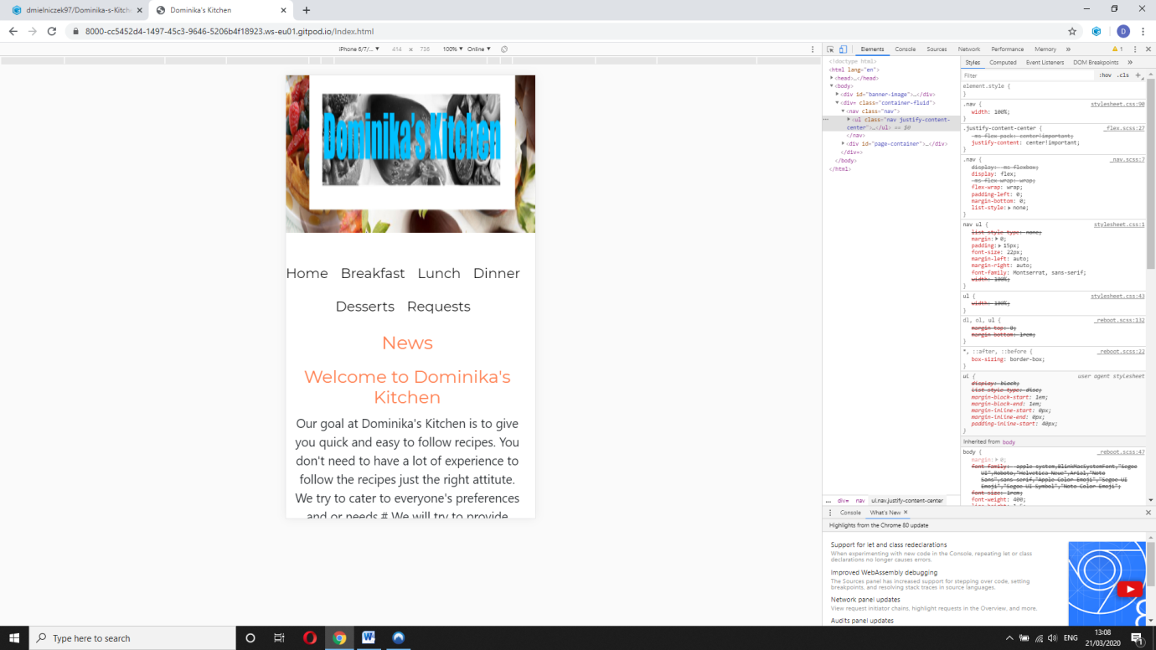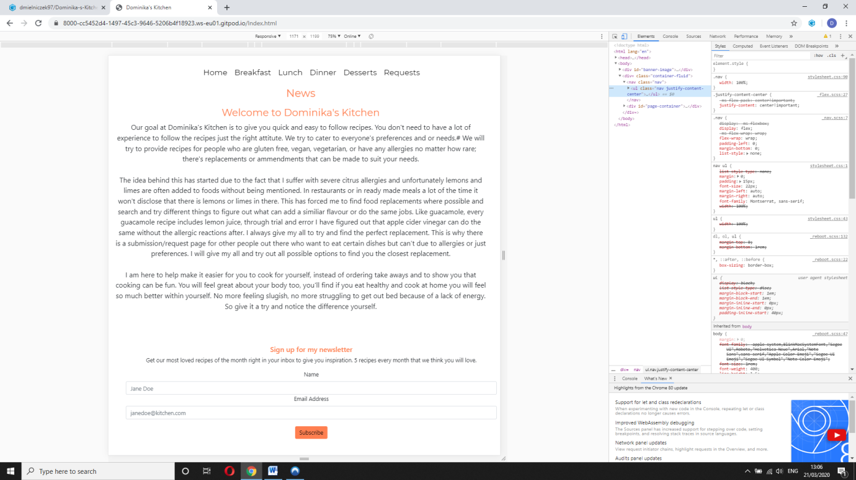On the index page, it’s the same case where the picture is not relevant and has been removed.

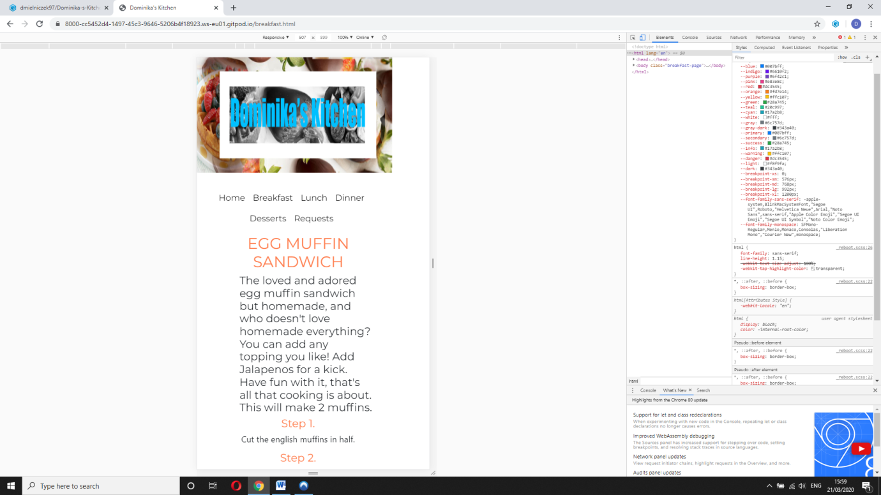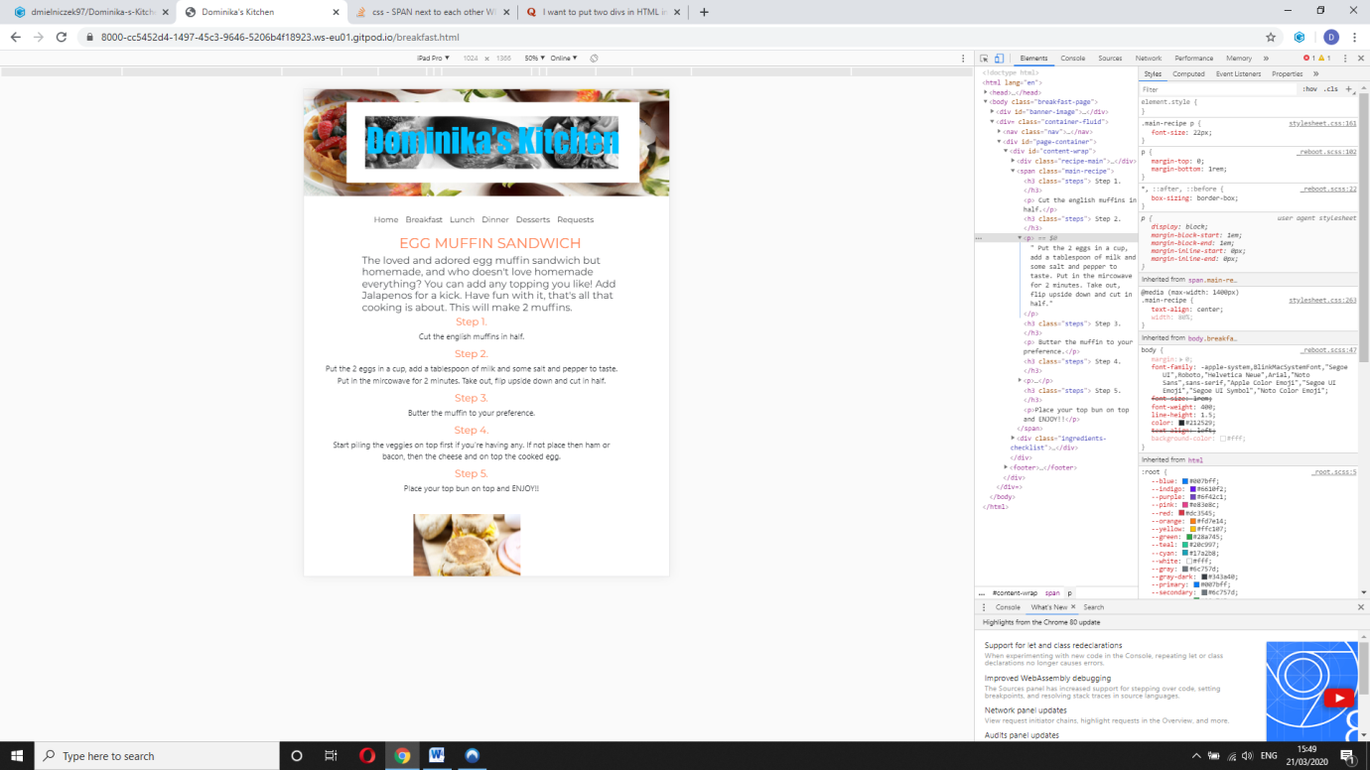The breakfast page on the tablet will look like this, all the content is still there, the image is lined underneath and so is the list of ingredients needed.

Submission form validation

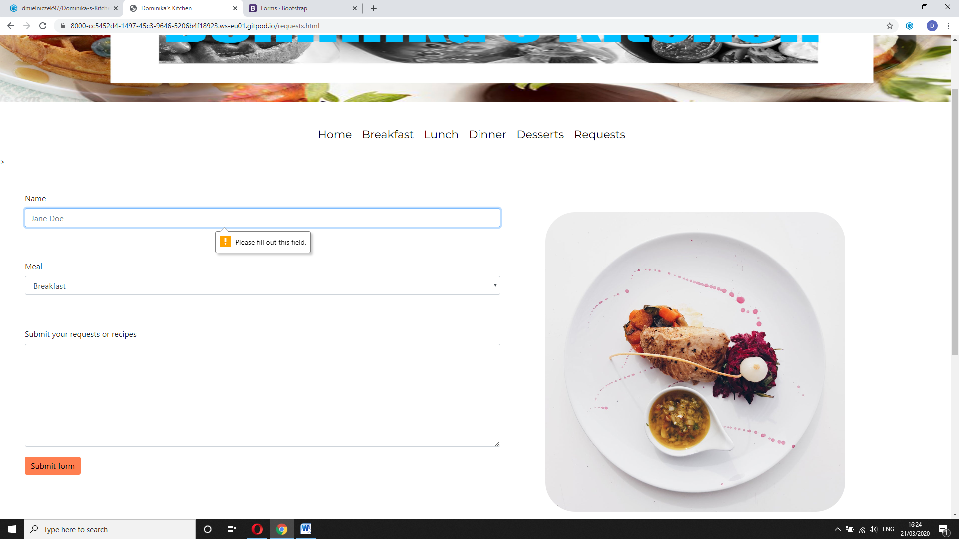

**Fixed issues**

I have encountered a couple of issues during the making of this process.

* When I was changing the CSS to make the websites responsive to smaller sizes, the English muffin image would not sit in the middle of the page. It’s inside a div and when I would highlight the div on the inspect page it was the full width of the page. However I couldn’t make the image sit in the middle. How I resolved it was I added a margin left and a margin right or 30% on both sides so the image would take up 40% of the page and sit in the middle.

**Unresolved issues**

* When the forms are submitted the data just disappears, there is no message to let them know that it had been submitted or that they have subscribed.
* When the breakfast page is loaded on devices with a width smaller than 700px, there seems to be a slight gap to the whole content on the right hand side. I have tried to do everything I knew how to, to fix this. I was unable to do so.